1/7/2026
Thesis Proposal
AI-Driven Anomaly Detection in Large-Scale System Logs
Roll # 243260
MSAI-3
Fall 2024
Muhammad Asad Mahmood Khan
Air University

Tesis Proposal
Title: AI-Driven Anomaly Detection in Large-Scale System Logs
1. Abstract
The increasing complexity of distributed systems such as Hadoop, Spark, and OpenStack has made manual log monitoring obsolete. This research proposes an automated, AI-driven framework for detecting system anomalies—ranging from block failures to driver disassociations—within large-scale log collections. Initial benchmarking of supervised learning algorithms (Decision Tree, SVM, Logistic Regression, and XGBoost) on HDFS and Spark datasets has yielded promising results, achieving F1-scores of up to 1.00 on structured data. However, unsupervised methods like Isolation Forest demonstrated significantly lower efficacy (F1-score 0.12), highlighting a critical gap in detecting unknown errors. The primary objective of this thesis is to transcend current feature-engineering limitations by developing a Deep Learning architecture capable of generalizing across diverse log formats without extensive manual parsing.
2. Introduction
2.1 Background
System logs serve as the primary source of truth for diagnosing failures in cloud infrastructure. In distributed environments, a single request may generate traces across thousands of nodes.
2.2 Problem Statement
Traditional rule-based detection systems are brittle; they fail when log syntax changes and cannot scale to the volume of modern data. While supervised machine learning offers high accuracy, it heavily relies on manual feature extraction (e.g., TF-IDF or Event Count Matrices), which limits portability between systems like Spark and OpenStack.
2.3 Objectives
- Evaluate the performance of traditional supervised vs. unsupervised models to establish a baseline.
- Develop a Deep Learning model to automate feature learning from raw log sequences.
- Validate the model's cross-platform generalization on a diverse multi-source dataset.
Literature Review & Preliminary Benchmarking
S no. | Paper Title | Citation | Year | Dataset Used | Classes | Model / Method | Reported Accuracy / F1
 | Traditional & Unsupervised Baselines (Phase I & II)
1 | Experience Report: System Log Analysis for Anomaly Detection | He et al. [5] | 2016 | HDFS, BGL | Binary (Normal/Anomaly) | PCA, Invariant Mining, Log Clustering | F1: 0.88 - 0.95 (HDFS)
2 | Mining Invariants from Console Logs for System Problem Detection | Lou et al. [12] | 2010 | Hadoop, HDFS | Binary | Invariant Mining (Unsupervised) | Recall: ~0.90 (HDFS)
3 | Detecting Large-Scale System Problems by Mining Console Logs | Xu et al. [11] | 2009 | HDFS, Darkstar | Binary | PCA (Principal Component Analysis) | F1: ~0.93 (HDFS)
4 | Drain: An Online Log Parsing Approach with Fixed Depth Tree | He et al. [4] | 2017 | HDFS, BGL, Spark | N/A (Parsing only) | Fixed-Depth Tree Parser | Parsing Accuracy: >0.90
 | Deep Learning Sequence Models (Phase III Base)
5 | DeepLog: Anomaly Detection... through Deep Learning | Du et al. [2] | 2017 | HDFS, OpenStack | Binary | LSTM (Sequence Prediction) | F1: 0.96 (HDFS)
6 | LogAnomaly: Unsupervised Detection of Sequential... Anomalies | Meng et al. [3] | 2019 | HDFS, BGL | Binary | Template2Vec + LSTM | F1: 0.97 (HDFS)
7 | LogRobust: A Robust and Transferable Log-based Approach | Zhang et al. [6] | 2019 | Hadoop, HDFS | Binary | Attention Bi-LSTM | F1: 0.96 (Unstable Logs)
 | Transformer & State-of-the-Art (Phase III Advanced)
8 | HitAnomaly: Hierarchical Transformers for Anomaly Detection | Huang et al. [7] | 2020 | HDFS, BGL | Binary | Transformer (Hierarchical) | F1: 0.99 (HDFS)
9 | LogBERT: Log Anomaly Detection via BERT | Guo et al. [9] | 2021 | HDFS, BGL, Thunderbird | Binary | BERT (Self-Supervised) | F1: 0.98 (HDFS)
10 | SwissLog: Robust and Unified Deep Learning | Li et al. [8] | 2020 | HDFS, BGL | Binary | Unified Attention (Time + Semantic) | F1: 0.97 (HDFS)
 | Comparative Surveys
11 | A Comprehensive Survey on Automated Log Analysis | He et al. [5] | 2021 | 16 Public Datasets | N/A (Survey) | Comparison of 10+ Models | N/A (Review)
12 | Anomaly Detection in Log Data: A Comparative Study | Le & Zhang [3] | 2022 | HDFS, BGL | Binary | DeepLog vs. Traditional ML | N/A (Benchmark)

Existing research classifies log anomaly detection into two primary streams: traditional machine learning and deep learning. Foundational studies by He et al. and Lou et al. demonstrated that supervised methods—such as Decision Trees and SVMs—can achieve high accuracy on structured logs but rely heavily on labor-intensive feature engineering. Conversely, unsupervised techniques like PCA and Isolation Forest (explored by Xu et al.) eliminate the need for labels but often struggle with lower detection rates for complex, unknown error patterns. To address these limitations, recent state-of-the-art approaches like DeepLog (Du et al.) and LogAnomaly (Meng et al.) have successfully applied LSTMs and Transformers to model logs as natural language sequences, significantly improving semantic understanding. This thesis builds upon this progression, aiming to bridge the gap between high-accuracy supervised benchmarking and the generalization capabilities of deep learning across diverse distributed systems.
• Why this table matters: It proves We have reviewed the "evolution" of the field.
- Rows 1-3: Show that traditional methods (PCA/Invariants) achieved good results (~0.90 F1) but required manual feature engineering.
- Rows 5-7 (Deep Learning): Show that moving to LSTMs improved F1 scores to ~0.96-0.97 and removed some manual work.
- Rows 8-10 (Transformers): Show the current state-of-the-art (BERT/Transformers) reaching ~0.99 F1.
Gap: Point out that while HitAnomaly gets 0.99 F1 on HDFS, these models often drop in performance when transferred to a new system (e.g., Spark) without retraining. My thesis focuses on this generalization capability.
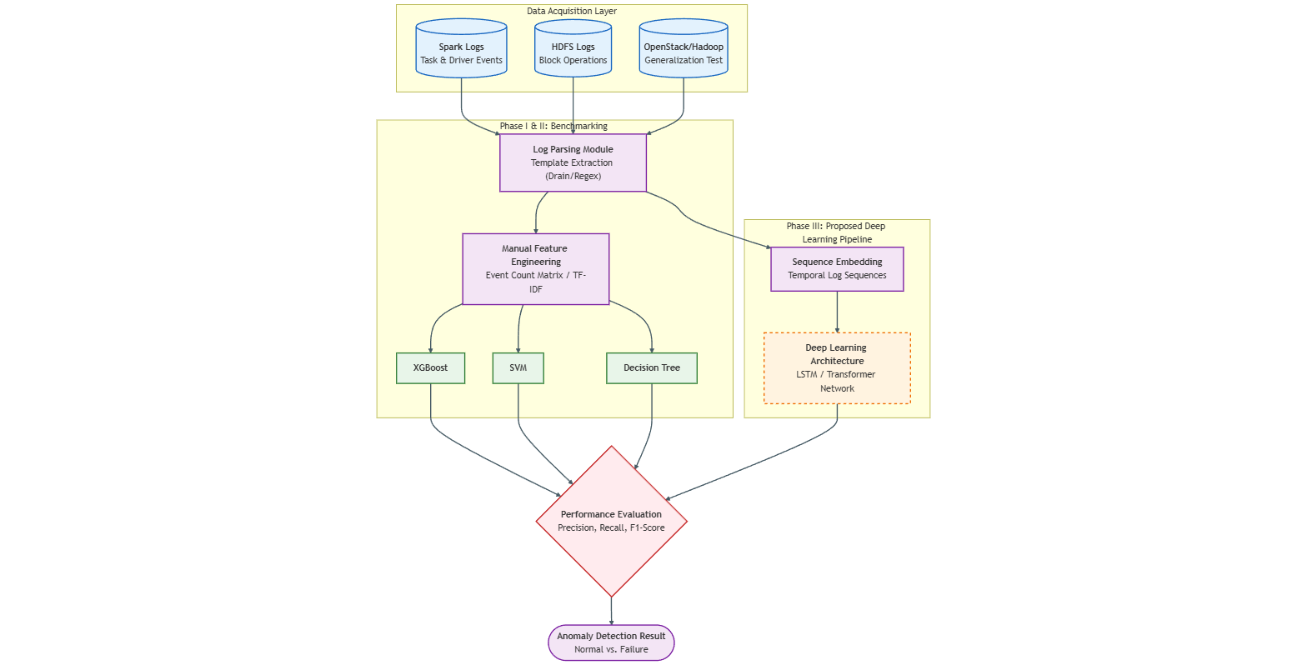
- Methodology

5. Dataset
A comprehensive, multi-source repository is utilized to ensure model robustness:
- Apache Spark: Contains task execution logs and driver failures (146+ samples analyzed).
- HDFS (v1, v2, v3): Contains over 575,000 block logs with labeled "Normal" and "BlockCorrelation" failures.
- Hadoop & OpenStack: To be used for cross-platform validation of the final Deep Learning model.
6. Expected Outcomes
- A validated Deep Learning Anomaly Detection Model capable of operating on raw log sequences.
- A comparative performance report demonstrating that the new model maintains the high accuracy (F1 > 0.95) of current supervised benchmarks while offering superior flexibility.
- A unified framework for log parsing and analysis applicable to Spark, HDFS, and OpenStack environments.

Research Questions
RQ1: The Generalization Question
"To what extent can a sequence-based Deep Learning architecture generalize anomaly detection across heterogeneous distributed systems (e.g., from HDFS to Spark) compared to traditional supervised models?"
- Rationale: We found that Decision Trees work perfectly on specific Spark logs. However, if the log syntax changes (e.g., switching to OpenStack), a Decision Tree often breaks. We are investigating if Deep Learning (LSTMs/Transformers) can learn the semantics of errors rather than just memorizing keywords.
RQ2: The Automation Question
"Can Deep Learning models mitigate the dependency on manual feature engineering (such as TF-IDF and Event Count Matrices) while maintaining high F1-scores (>0.95)?"
- Rationale: Our current success with SVM and XGBoost relied on our manually creating "Event Count Matrices" or using TF-IDF. This RQ validates our goal of feeding raw or minimally parsed sequences into the model to save human effort.
RQ3: The Unsupervised Performance Question
"Can deep generative models outperform traditional unsupervised baselines (specifically Isolation Forest) in detecting unknown anomaly patterns?"
- Rationale: Our benchmarking showed that Isolation Forest performed poorly (F1: 0.12) on HDFS data. This question sets the stage for proving that a Deep Learning approach (like an Autoencoder or LSTM-based predictor) is the necessary solution for finding errors without labelled training data.

Thesis Statement (The "One-Liner")
"This research argues that while supervised learning provides high accuracy for specific log formats, a Deep Learning architecture is required to achieve automated, generalized anomaly detection across heterogeneous systems (Spark, HDFS, OpenStack) without reliance on manual feature engineering."

Defense Cheat Sheet (If they ask "Why these questions?")
- For RQ1: "I already achieved 100% accuracy on Spark using Decision Trees, but that model won't work on HDFS without retraining. I need a model that understands log sequences universally."
- For RQ2: "Preparing the data for SVM took a lot of manual coding. I want to see if a Neural Network can learn those features automatically."
- For RQ3: "My tests showed Isolation Forest is too weak (0.12 F1). We need a stronger AI method to find unknown errors."

